This task needs to be done only when you get change from user or you have very old snapshot With approval of CLA to delete it.

Delete old OS Image and associated snapshots

Search **atapcustomimagesvhdstore** - ---🡪 containers ---🡪 atos image

While user ticket you have to go to user accounts in : --🡪 containers ----🡪 user image

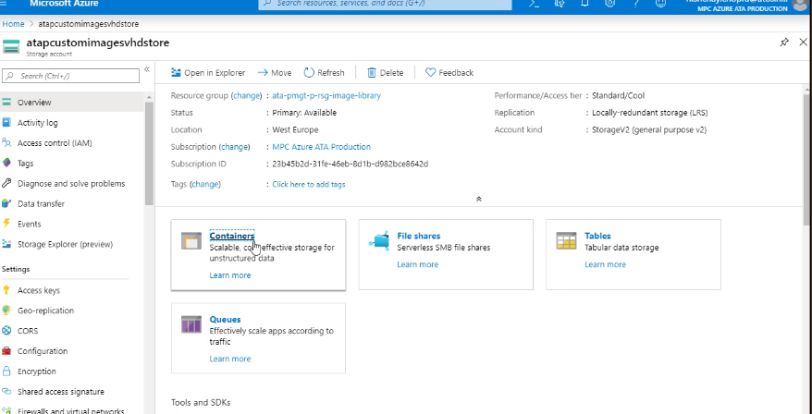

Delete old images with proper change requests

